Lab Guideline

Topics
- VLANs and Trunking: IEEE 802.1Q
- Inter-VLAN routing

- VLANs and Trunking

Laboratory test configuration:

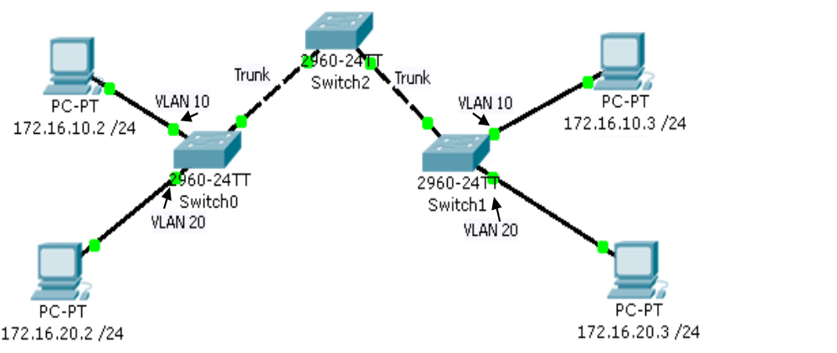
IMPORTANT! Create VLAN 10 and 20 on all switches!
Commands Used:

Switch>enable
Switch#configure terminal
Switch(config)#vlan 10
Description: Global configuration command that creates VLAN 10

Switch(config-vlan)#name Student_Vlan
Description: Assigns a name to the VLAN

Switch#show vlan brief
Description: Displays VLANs information (the contents of the vlan.dat file )

Switch(config)#interface fa 0/1
Switch(config-if)#switchport mode access
Switch(config-if)#switchport access vlan 10
Description: Configures a port as an access port and assigns VLAN 10 to an access port

Switch(config)#interface fa 0/2
Switch(config-if)#switchport mode trunk
Description: Configures a port as a trunk port

Switch#show interfaces trunk
Description: Displays trunking information for the switch

Repeat the above steps for the other interfaces an the corresponding switches

Test the connectivity.
- Inter-VLAN routing

Laboratory test configuration:

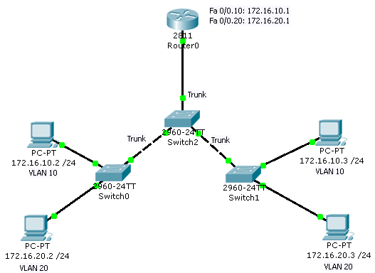

Commands Used:

Router(config)#interface fastethernet 0/0
Router(config-if)#no shutdown
Description: Enable Fa0/0 interface

Router(config)#interface fastethernet 0/0.10
Description: Creates a subinterface numbered 10 on the router for Fa0/0

Router(config-subif)#encapsulation dot1q 10
Description: Specifies IEEE 802.1Q as the VLAN tagging method for VLAN 10 on this subinterface

Router(config-subif)#ip address 172.16.10.1 255.255.255.0
Description: Add an IP address on Fa0/0.10 subinterface

Repeat the above steps to create the second subinterface (fastEthernet 0/0.20) on the router

Also, on Switch2, configure the interface connecting the router in Trunk mode. Why is that necessary?

Router#show ip route
Description: Visualize the routing table

Add Gateways to PCs - the IP addresses set on the Multilayer Switch for the respective VLAN:
- 172.16.10.1 for devices in VLAN 10
- 172.16.20.1 for devices in VLAN 20

Test the connectivity.
ping <IP>
tracert <IP>

